**22CB903  
MINI-PROJECT 3**

OBJECTIVE:

The goal is to group customers into distinct segments based on their characteristics.

ALGORITHM:

Data Preprocessing:

1. Load the customer dataset using pandas
2. Inspect the dataset to understand its structure using .head() and .info() methods.
3. Check for missing values using isnull().sum().

Feature Selection:

1. Extract the features of interest: Annual Income (k$) and Spending Score (1-100) using the iloc method. These will be used as input for clustering (X = customer_data.iloc[:, [3,4]].values).

Finding Optimal Number of Clusters (Elbow Method):

1. Initialize an empty list wcss = [] to store the Within-Cluster Sum of Squares (WCSS) for different numbers of clusters.

1. For each cluster number i (ranging from 1 to 10), perform the following:

* Initialize a K-Means model with i clusters using kmeans = KMeans(n_clusters=i, init='k-means++', random_state=42).
* Fit the model to the selected features using kmeans.fit(X).
* Append the WCSS (inertia) to the list wcss.append(kmeans.inertia_).

1. Plot the WCSS against the number of clusters to visualize the "elbow" point. This elbow point indicates the optimal number of clusters.

Applying K-Means Clustering:

1. Based on the elbow method, choose the optimal number of clusters.
2. Initialize the K-Means model with the chosen number of clusters (e.g., kmeans = KMeans(n_clusters=5, init='k-means++', random_state=0)).
3. Fit the model to the data and assign each customer to a cluster based on the closest centroid.

Visualization:

1. Plot the results of the clustering, where each cluster is represented by a different color to show how customers are grouped.

CODE:

# %%

import numpy as np

import pandas as pd

import matplotlib.pyplot as plt

import seaborn as sns

from sklearn.cluster import KMeans

# %%

# loading the data from csv file to a Pandas DataFrame

customer_data = pd.read_csv('Mall_Customers.csv')

# %%

# first 5 rows in the dataframe

customer_data.head()

# %%

# finding the number of rows and columns

customer_data.shape

# %%

# getting some informations about the dataset

customer_data.info()

# %%

# checking for missing values

customer_data.isnull().sum()

# %%

X = customer_data.iloc[:,[3,4]].values

print(X)

# %%

# finding wcss value for different number of clusters

wcss = []

for i in range(1,11):

kmeans = KMeans(n_clusters=i, init='k-means++', random_state=42)

kmeans.fit(X)

wcss.append(kmeans.inertia_)

# %%

# plot an elbow graph

sns.set()

plt.plot(range(1,11), wcss)

plt.title('The Elbow Point Graph')

plt.xlabel('Number of Clusters')

plt.ylabel('WCSS')

plt.show()

# %%

kmeans = KMeans(n_clusters=5, init='k-means++', random_state=0)

# return a label for each data point based on their cluster

Y = kmeans.fit_predict(X)

print(Y)

# %%

# plotting all the clusters and their Centroids

plt.figure(figsize=(8,8))

plt.scatter(X[Y==0,0], X[Y==0,1], s=50, c='green', label='Cluster 1')

plt.scatter(X[Y==1,0], X[Y==1,1], s=50, c='red', label='Cluster 2')

plt.scatter(X[Y==2,0], X[Y==2,1], s=50, c='yellow', label='Cluster 3')

plt.scatter(X[Y==3,0], X[Y==3,1], s=50, c='violet', label='Cluster 4')

plt.scatter(X[Y==4,0], X[Y==4,1], s=50, c='blue', label='Cluster 5')

# plot the centroids

plt.scatter(kmeans.cluster_centers_[:,0], kmeans.cluster_centers_[:,1], s=100, c='cyan', label='Centroids')

plt.title('Customer Groups')

plt.xlabel('Annual Income')

plt.ylabel('Spending Score')

plt.show()

OUTPUT:

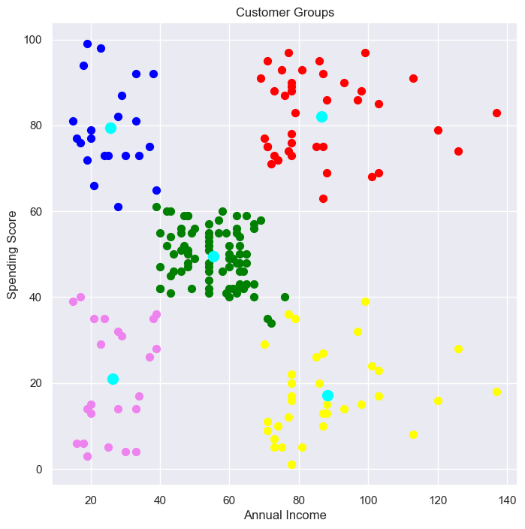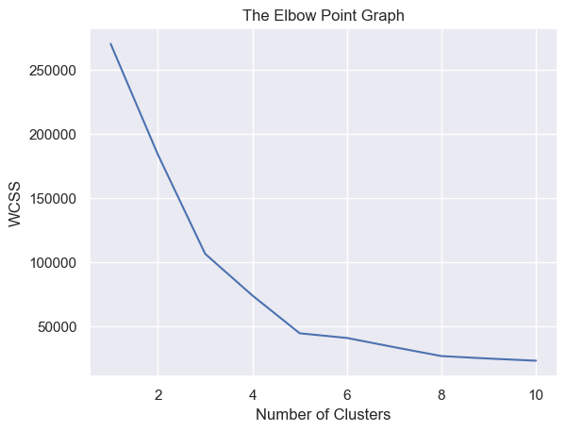

*By*

*S Sharvesh Guru*

*CSBS* | *111722202043*